Sahu Cloth House

Optimizing Retail Sales and Stock Management for Sahu Cloth House

A Proposal Report for the BDM Capstone Project

Submitted by:

Name: Deepanshi
Roll number: 22f1000455



IITM Online BS Degree Program,

Indian Institute of Technology, Madras,

Chennai Tamil Nadu, India, 600036

Declaration Statement

I am working on a Project Titled “Optimizing Retail Sales and Stock Management Using Data Analytics”. I extend my appreciation to Sahu Cloth House, for providing the necessary resources that enabled me to conduct my project.

I hereby assert that the data presented and assessed in this project report is genuine and precise to the utmost extent of my knowledge and capabilities. The data has been gathered through primary sources and carefully analyzed to assure its reliability.

Additionally, I affirm that all procedures employed for the purpose of data collection and analysis have been duly explained in this report. The outcomes and inferences derived from the data are an accurate depiction of the findings acquired through thorough analytical procedures.

I am dedicated to adhering to the information of academic honesty and integrity, and I am receptive to any additional examination or validation of the data contained in this project report.

I understand that the execution of this project is intended for individual completion and is not to be undertaken collectively. I thus affirm that I am not engaged in any form of collaboration with other individuals, and that all the work undertaken has been solely conducted by me. In the event that plagiarism is detected in the report at any stage of the project's completion, I am fully aware and prepared to accept disciplinary measures imposed by the relevant authority.

I agree that all the recommendations are business-specific and limited to this project exclusively, and cannot be utilized for any other purpose with an IIT Madras tag. I understand that IIT Madras does not endorse this.

Signature of Candidate:

Name: Deepanshi

Date: 02-03-2025

CONTENTS

Executive Summary 2

Organization Background 2

Problem Statement 2-3

Background of the Problem 3

Problem Solving Approach 3-4

Expected Timeline 5

Expected Outcome 5

Executive Summary
Sahu Cloth House is a retail store in Ranila, Haryana, offering B2C sales of apparel, household essentials, packaged food, and wellness supplements.
This project will leverage advanced data analytics to address core business challenges with a strategic focus on maximizing profitability, optimizing inventory management, and enhancing overall operational efficiency. By systematically analyzing historical and real-time data, the initiative aims to uncover hidden patterns, inefficiencies, and opportunities for growth.
The approach integrates a suite of proven analytics techniques—including Pareto analysis to prioritize key revenue drivers, performance analysis to evaluate sales and staff productivity, and trend analysis to anticipate shifts in customer preferences and market demand. These methodologies will enable the identification of high-impact issues and the formulation of data-driven, actionable strategies.

Organization Background
Sahu Cloth House is a retail business specializing in apparel and general merchandise, based in Ranila, Haryana. It was established on January 29, 2022, initially focusing on ladies' suits before expanding its product range to include various clothing items and household essentials.
The store is managed by Mrs. Monti Sahu, who transitioned into entrepreneurship to focus on business growth. Operating from the family’s residence, the store has built a loyal customer base in the local area. As demand increases, Mrs. Sahu aims to expand the business by improving operations and reaching a wider audience.

Problem Statement
Through discussions with the owner, I identified several key challenges affecting Sahu Cloth House’s growth and profitability.
- Low Profitability: Excessive borrowing, less revenue generation, and poor cash flow management are reducing net profits and hindering reinvestment in the business.
- Inventory Inefficiency: Overstocking of slow-moving items and frequent stockouts of high-demand products lead to lost sales and increased holding costs.
- Underperforming Product Lines: Health supplements and certain apparel categories contribute minimally to overall sales, resulting in wasted shelf space and tied-up capital.

Background of the Problem
Sahu Cloth House is facing multiple operational challenges that hinder its growth and profitability. These issues arise due to gaps in inventory management, financial planning, and business expansion strategies.
- Financial Instability: The business relies on short-term loans to manage working capital, resulting in high interest costs and reduced net income.
- Inventory Management Gaps: Lack of systematic demand forecasting leads to frequent overstocking of slow-moving items and stockouts of bestsellers. This not only increases holding costs but also results in lost sales opportunities.
- Sales Concentration: Analysis reveals that a small subset of products accounts for the majority of sales, while others contribute little, indicating suboptimal product assortment.
- Operational Blind Spots: Without tools such as sales dashboards or performance analysis, the business cannot proactively address declining trends or capitalize on emerging opportunities

Problem Solving Approach
To address the business challenges at Sahu Cloth House, a structured, data-driven problem-solving approach was implemented. The steps below illustrate how data analytics techniques were applied to identify root causes, prioritize actions, and develop targeted solutions for sustainable business growth.

Step 1: Identifying and Defining the Core Problems
The first step involved clearly defining the problems affecting the store’s profitability and growth. This will be achieved by:
- Reviewing weekly sales and revenue data to spot declining trends and underperforming product categories.
- Engaging with the store owner to understand operational pain points, such as cash flow issues and customer complaints about delivery.

Step 2: Analyzing Sales and Inventory Performance
To understand which products and categories most significantly impacted business outcomes, the following analyses will be conducted:
- Pareto Analysis: Using the 80/20 principle, sales and revenue data will be analyzed to identify that a small number of products contributed to most of the revenue, while several items had minimal sales or revenue share. This will help focus attention on high-impact products and flag slow movers for review.
- Performance Analysis: Weekly and monthly sales trends will be visualized using pivot tables and charts in Excel. This will help identify peak sales periods, products with consistent demand, and those with declining or stagnant sales.
- Trend Analysis: By plotting sales over time, seasonal patterns and sudden drops in revenue can be identified, allowing for better inventory planning and promotional timing.

Step 3: Prioritizing Solutions and Action Planning
Based on the data insights, solutions can be prioritized for maximum impact:
- Inventory Optimization: Focusing on maintaining adequate stock for bestsellers while reducing purchases of slow-moving products, thus improving cash flow and reducing waste.
- Targeted Promotions: Developing specific campaigns and collaborations (e.g., with local gyms) to boost awareness and sales of underperforming categories like health supplements.
- Financial Management: Recommending digital tools for real-time tracking of income and expenses and introducing incentives for early payments to ease cash flow.

Data and Tools Used
- Data Sources: Weekly sales and revenue data, inventory logs, and owner interviews.
- Analytical Tools: Microsoft Excel (pivot tables, Pareto charts, trend graphs), qualitative feedback.
- Visualization: Bar graphs, pie charts for clear presentation of findings and progress.

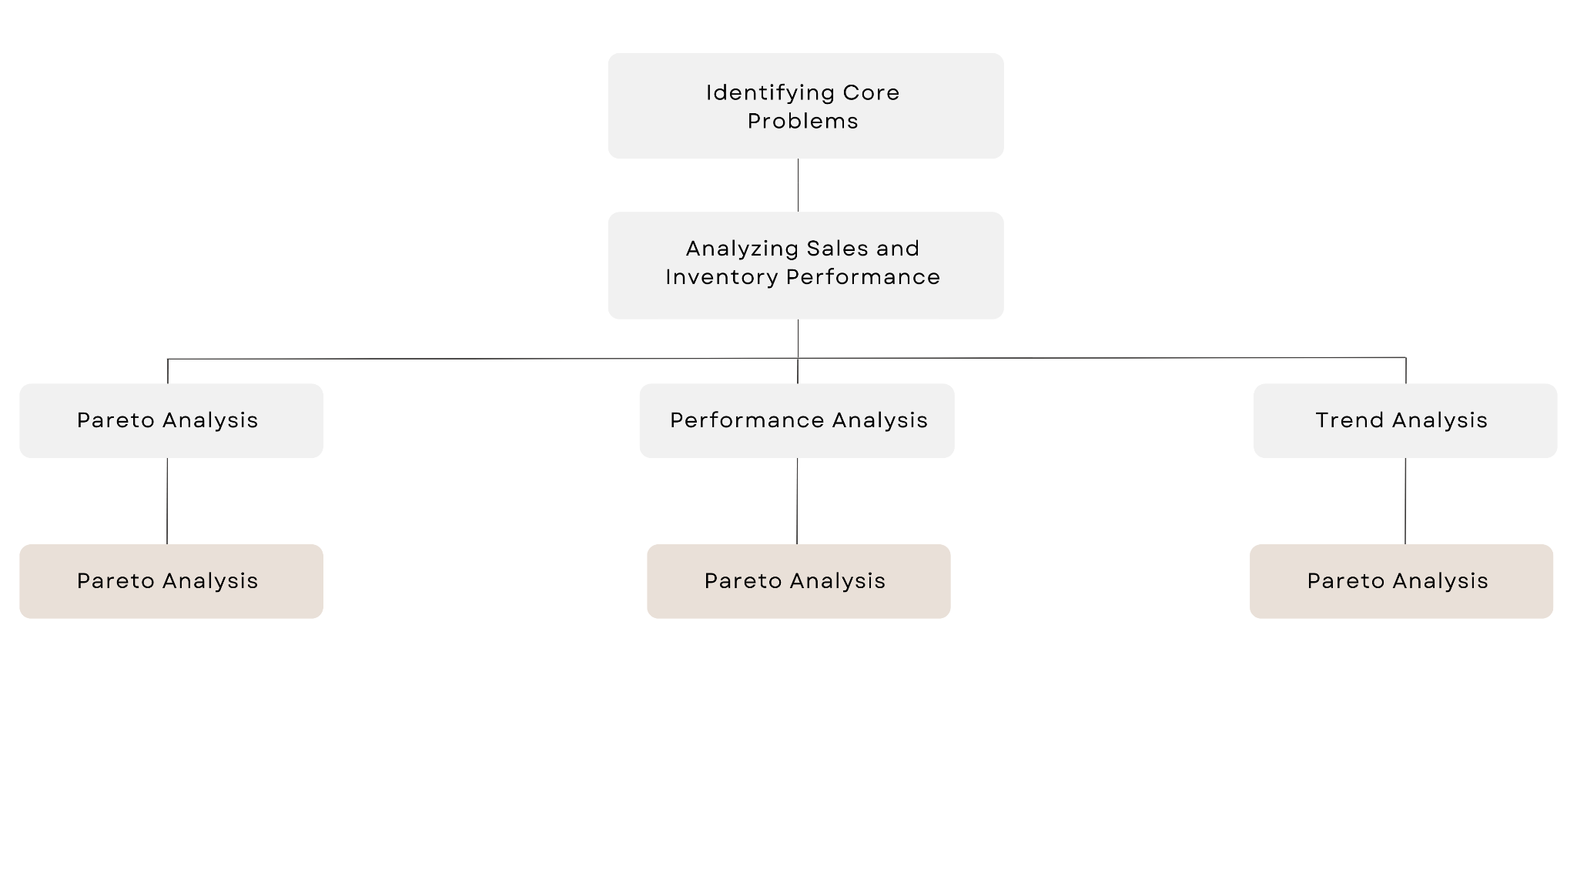

Expected Timeline

Work Breakdown Structure:
- Discussion with Owner: 6 - 9 May
- Project Proposal: 11 - 13 May
- Data Collection: 13 - 14 May
- Data Cleaning: 15 - 17 May
- Data Analysis: 17 - 19 May
- Analysis Completion & Submission: 19 - 30 May

Gantt Chart: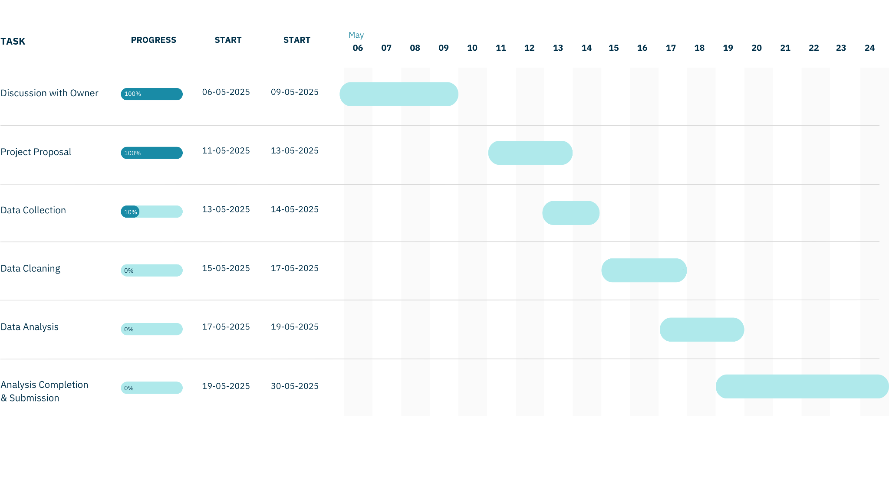

Expected Outcome
This project aims to bridge the gap between theoretical knowledge and practical application by analyzing real business data. By leveraging tools like Excel, I intend to extract meaningful insights that will drive decision-making. The expected outcomes include:
- Optimized Inventory Management – Identifying stock patterns to prevent overstocking and stockouts.
- Sales Performance Analysis – Understanding sales trends, particularly for underperforming products, and developing strategies to boost their sales.
- Business Growth Strategies – Providing data-driven recommendations to enhance revenue and expand the business.

